GROUPED BAR CHART - Q1 SALES BY PRODUCT
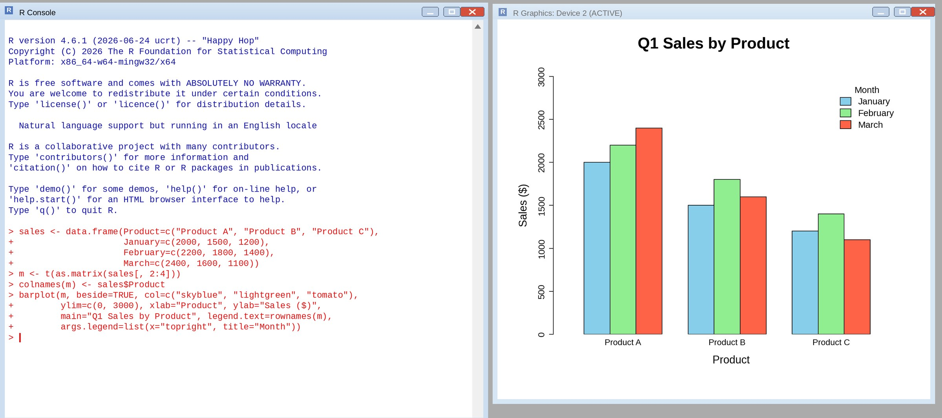
STACKED AREA CHART - OVERALL SALES TREND
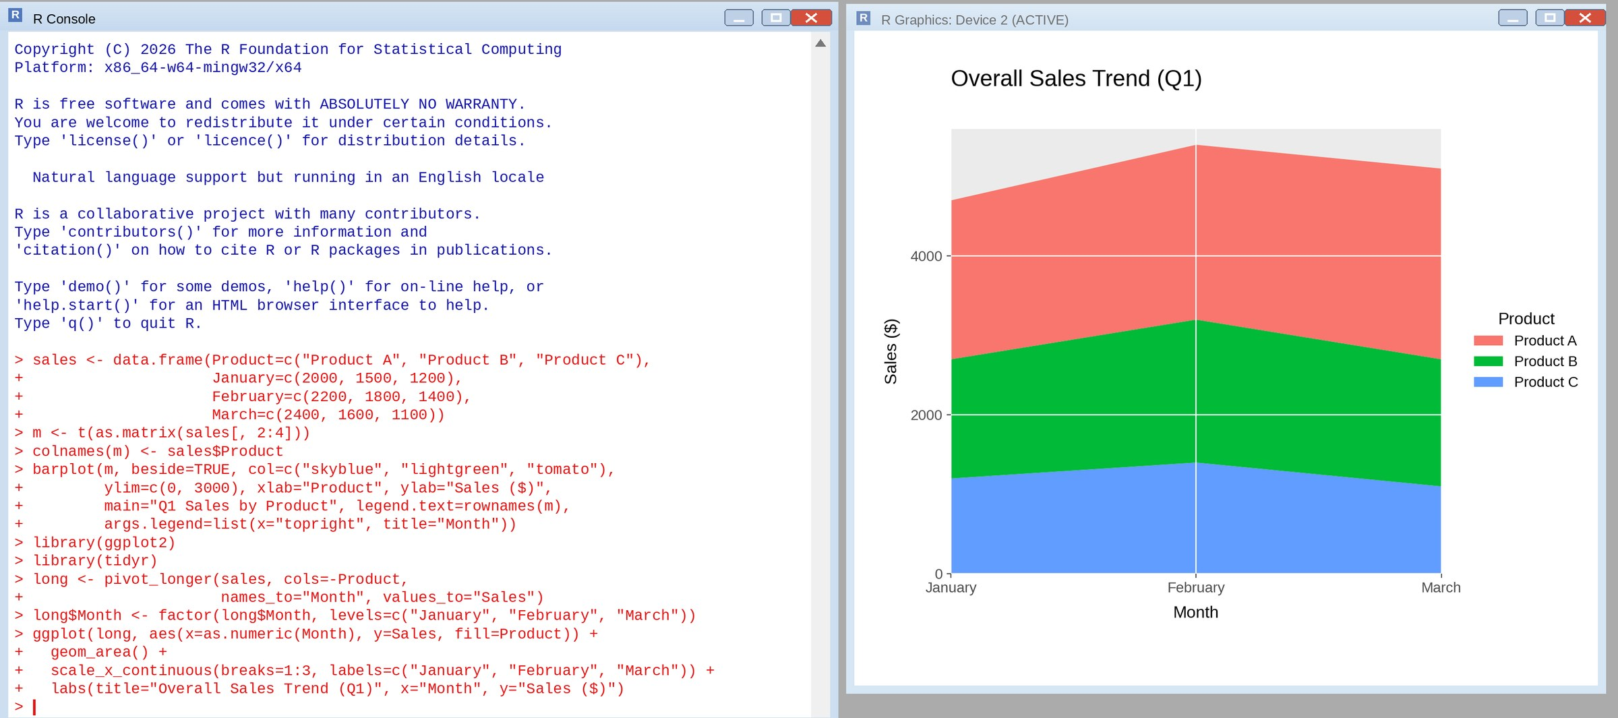
TABLE - MONTHLY PRODUCT SALES
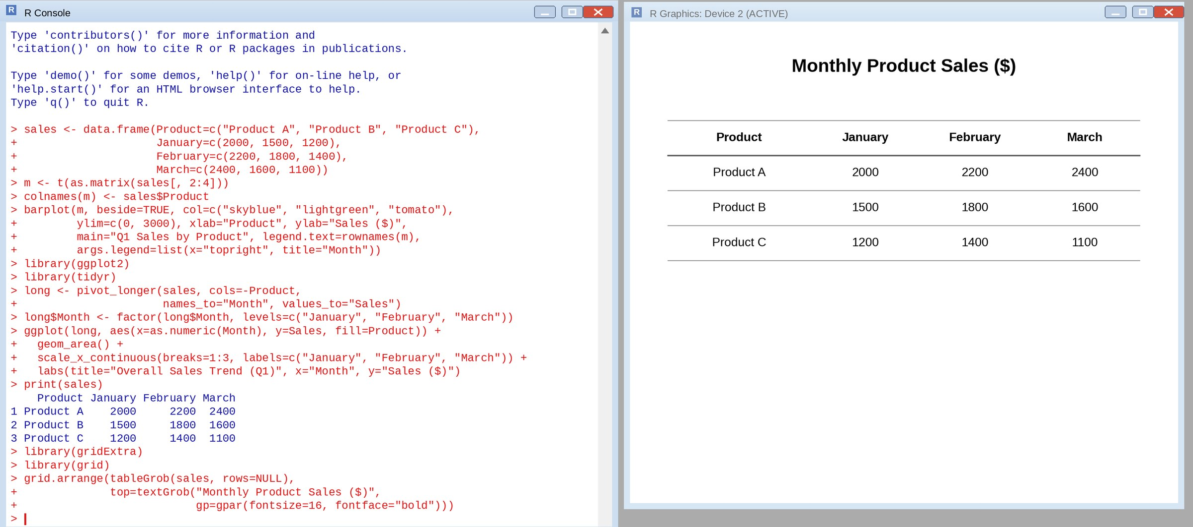
TABLEAU DASHBOARD - GROUPED BAR CHART, STACKED AREA CHART AND TABLE
